Palm Beach FCAT, Graduation, and Contact Letter Report Processing
Steps required in order to upload FCAT, Graduation, or Contact Letter reports using Livelink 3.4
- Data files need to be prepared and placed in the appropriate folder for processing
- Reports have to be defined
- User accounts have to be added

Login to Livelink 3.4 as District Super User (pbuploade1/test)

Placing Files into Livelink Directory Path for Processing

Before Uploading FCAT and Graduation reports to Edline, data files need to be prepared and the files are to be placed in the appropriate folder for processing.

The default folder used for processing can be located:

For Windows XP machines:
C:\AllUsers\Application Data\Livelink\Palm_Beach_County\Data\GenericUploads

For Windows 7 machines:
C:\ProgramData\Livelink\Palm_Beach_County\Data\GenericUploads

To change the default path to another location on you network.
- Select ‘Tools>Setup Directory Paths…’

- Navigate to the folder where data files are located, and click ‘OK’

- Click ‘OK’ button

Defining Upload Reports

Defining the FCAT Report

- Click ‘Tools>Manage Report Definitions…’
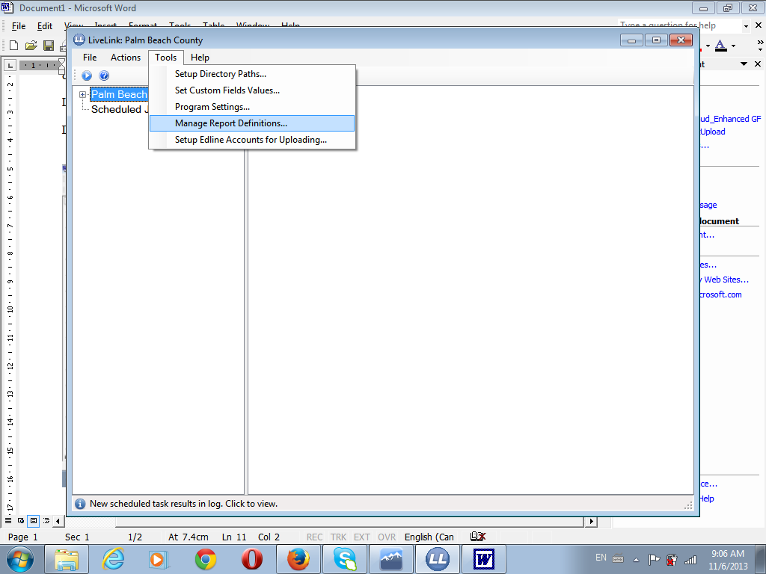

- Click ‘Add Report’ button located on the ‘Manage Report Definitions’ page
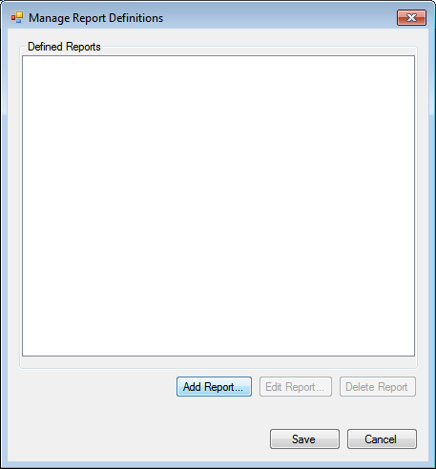

- Select ‘FCAT/NRT Home Report’ from the ‘Report Type’ dropdown located on ‘Add Report’ page
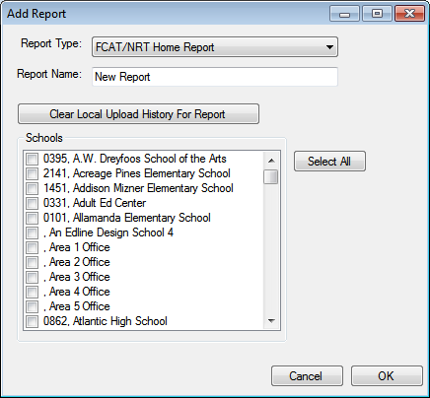

- Type the name of the report in the ‘Report Name’ field (this is the name you would like the report called on Edline (ie. Student Assessment Report))

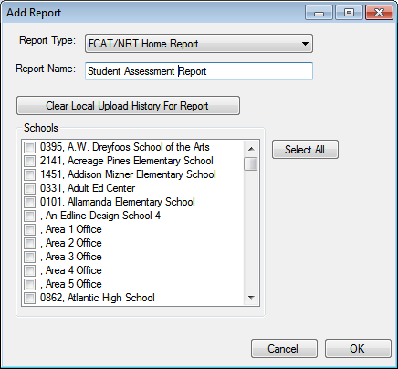

Livelink keeps local record of the previous upload of the FCAT report. The file is called ‘fcat.map’ and can be located in your ‘C:\Edline\LivelinkWeb’ directory. When running the report, Livelink checks the upload records, with the previously ran (fcat.map) and uploads ONLY the records that have been changed since the last time the report was ran.

If a complete upload of ALL files is required, or you want to force an upload to one or more schools, the user can clear the previously ran local history.

- The schools you would like to clear the history for, select the checkbox to the left of the school, located in the ‘Schools’ box. For all schools, click the ‘Select All’ button
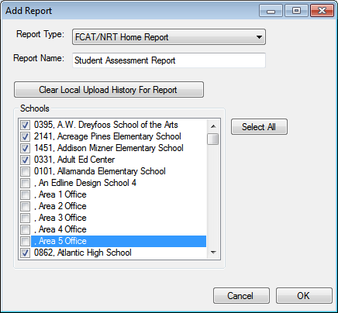

- Click the ‘Clear Local Upload History for the Report’ button.
- Click ‘OK’ button to save the report

Defining the Graduation Report
- Click ‘Tools>Manage Report Definitions…’

- Click ‘Add Report’ button located on the ‘Manage Report Definitions’ page
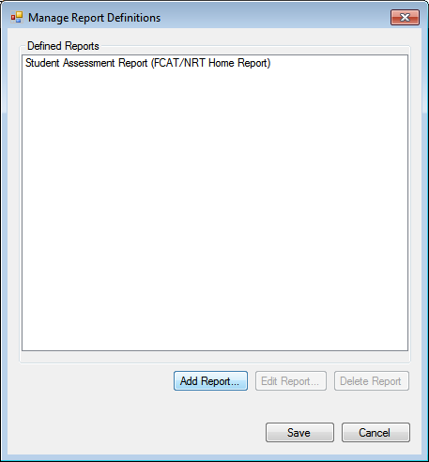

- Select ‘Graduation Report’ from the ‘Report Type’ dropdown located on ‘Add Report’ page
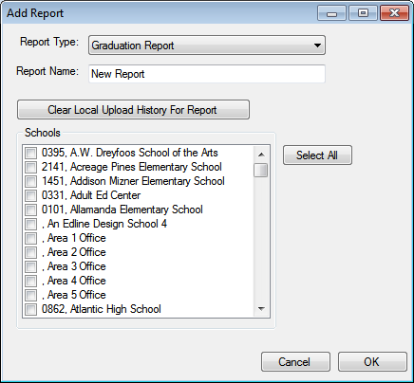

- Type the name of the report in the ‘Report Name’ field (this is the name you would like the report called on Edline (ie. Individual Student Graduation Status -RSSOA0549))

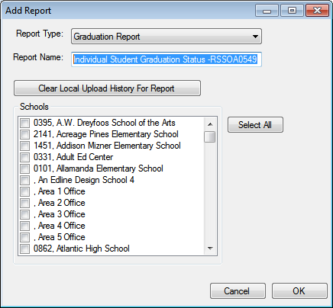

Livelink keeps local record of the previous upload of the Graduation report. The file is called ‘grad.map’ and can be located in your ‘C:\Edline\LivelinkWeb’ directory. When running the report, Livelink checks the upload records, with the previously ran (grad.map) and uploads ONLY the records that have been changed since the last time the report was ran.

If a complete upload of ALL files is required, or you want to force an upload to one or more schools, the user can clear the previously ran local history.

- The schools you would like to clear the history for, select the checkbox to the left of the school, located in the ‘Schools’ box. For all schools, click the ‘Select All’ button
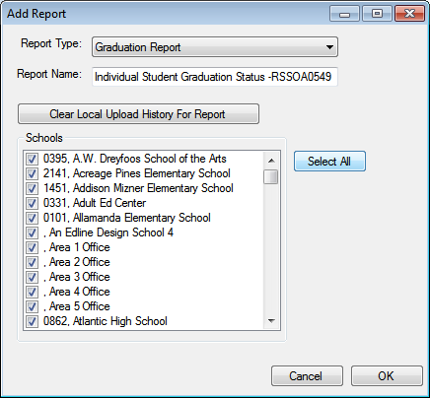

- Click the ‘Clear Local Upload History for the Report’ button.
- Click ‘OK’ button to save the report
- Click ‘Save’ button on ‘Manage Report Definitions’ page

Defining the Contact Letter Report
- Click ‘Tools>Manage Report Definitions…’

- Click ‘Add Report’ button located on the ‘Manage Report Definitions’ page

- Select ‘Contact Letter Report’ from the ‘Report Type’ dropdown located on ‘Add Report’ page

- Type the name of the report in the ‘Report Name’ field (this is the name you would like the report called on Edline (ie. User Contact Letter)

The Email field defaults to ‘ftetech@palmbeachschools.org’, and can be changed

Livelink keeps local record of the previous upload of the Graduation report. The file is called ‘contact.map’ and can be located in your ‘C:\Edline\LivelinkWeb’ directory. When running the report, Livelink checks the upload records, with the previously ran (contact.map) and uploads ONLY the records that have been changed since the last time the report was ran.

If a complete upload of ALL files is required, or you want to force an upload to one or more schools, the user can clear the previously ran local history.

- The schools you would like to clear the history for, select the checkbox to the left of the school, located in the ‘Schools’ box. For all schools, click the ‘Select All’ button

- Click the ‘Clear Local Upload History for the Report’ button.
- Click ‘OK’ button to save the report
- Click ‘Save’ button on ‘Manage Report Definitions’ page

Setup Edline Accounts for Uploading
In order to upload a large quantity of reports, Livelink will require several District SuperUser accounts to handle the processing on Edline. These accounts needed to be defined in Livelink along with the password for each account being defined.

- Select ‘Tools>Setup Edline Accounts for Uploading’
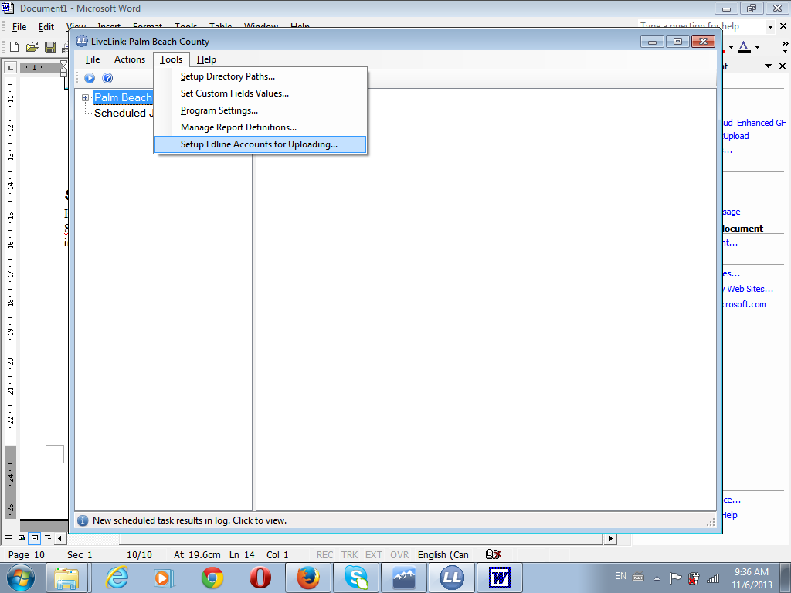

- Click ‘Add Account’ button located on the ‘Upload Accounts Configuration’ page
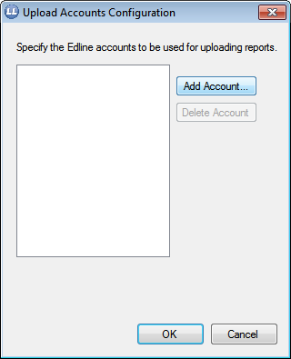
- Add the District SuperUser accounts and passwords on the ‘Add Account’. There are ten District SuperUser accounts created on Edline, and these accounts are used for uploading FCAT and Graduation reports (pbuploade1, pbuploade2,….., pbuploade10, all accounts with the password of ‘test’)
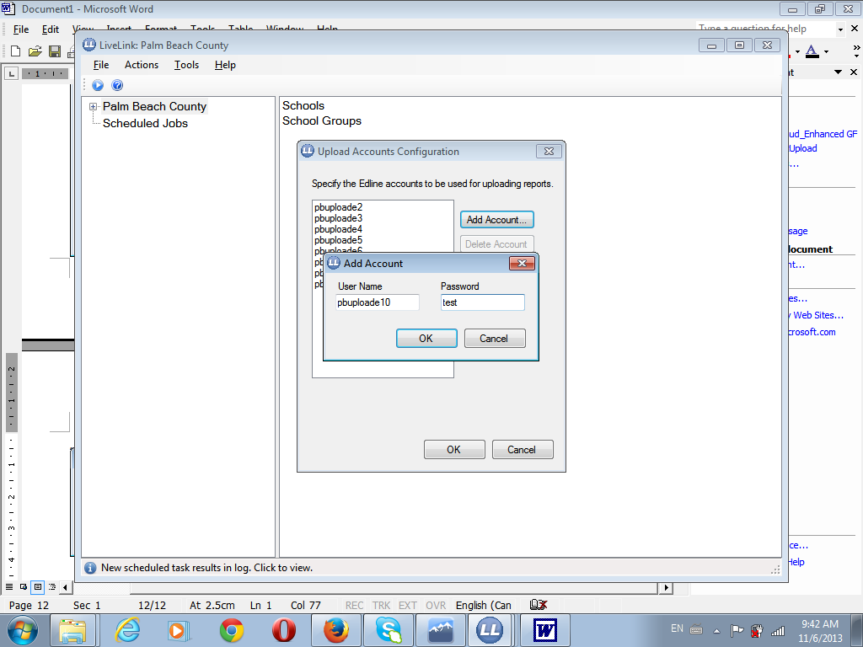

Note: Do not add the District SuperUser account currently used to log into Livelink (ie. Pbuploade1 is used to login to Livelink and is not added as an upload account)

- Click ‘OK’ button on ‘Upload Accounts Configuration’ page when all accounts have been added.

Running the FCAT Report
- Click ‘Actions>Run Process…’
- Select ‘Generic Upload to Edline’ from the ‘Process to Run’ dropdown located on the ‘Run Livelink Process’ page
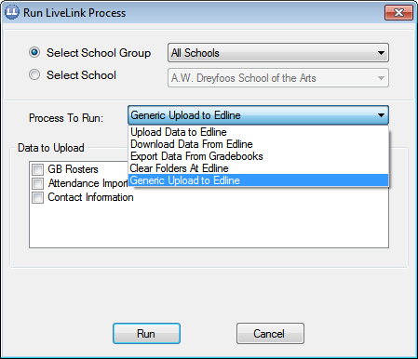

- Select ‘Student Assessment Report FCAT/NRT Home Report’ from the ‘Data to Upload’ dropdown
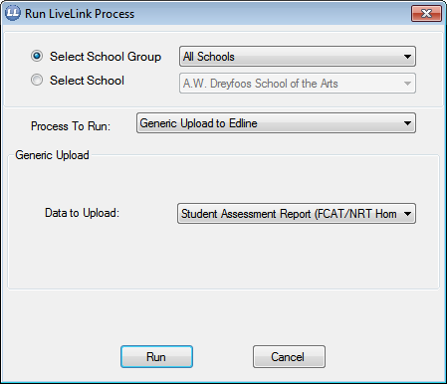

- Click ‘Run’ button
- When report has completed uploading, the results are displayed
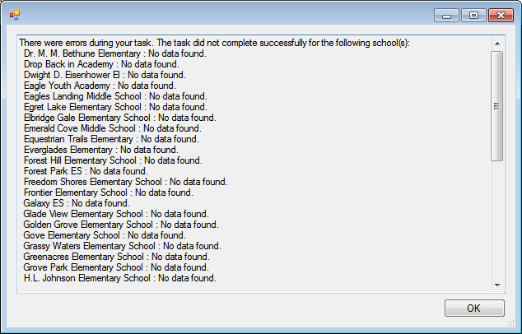

Running the Graduation Report
- Click ‘Actions>Run Process…’
- Select ‘Generic Upload to Edline’ from the ‘Process to Run’ dropdown located on the ‘Run Livelink Process’ page

- Select ‘Individual Graduation Status Report – RSSOA0549’ from the ‘Data to Upload’ dropdown
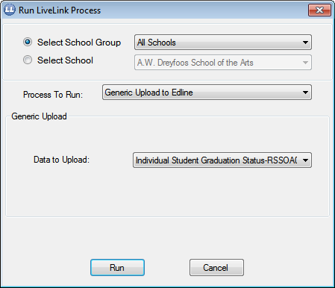

- Click ‘Run’ button
- When report has completed uploading, the upload results are displayed

